

Locating Contracts Process Manual

Table of Contents

Introduction 3

BidBuy Home Page 4

Contract Search 5

# Introduction

BidBuy is the State of Illinois’s web based eProcurement system, designed to streamline procurement processes and offer expanded services.

State of Illinois governmental units who are eligible to use state contracts can use the following instructions to search for contracts that may meet its needs.

# BidBuy Home Page

To access the BidBuy homepage shown below, use <https://www.bidbuy.illinois.gov/bso/>

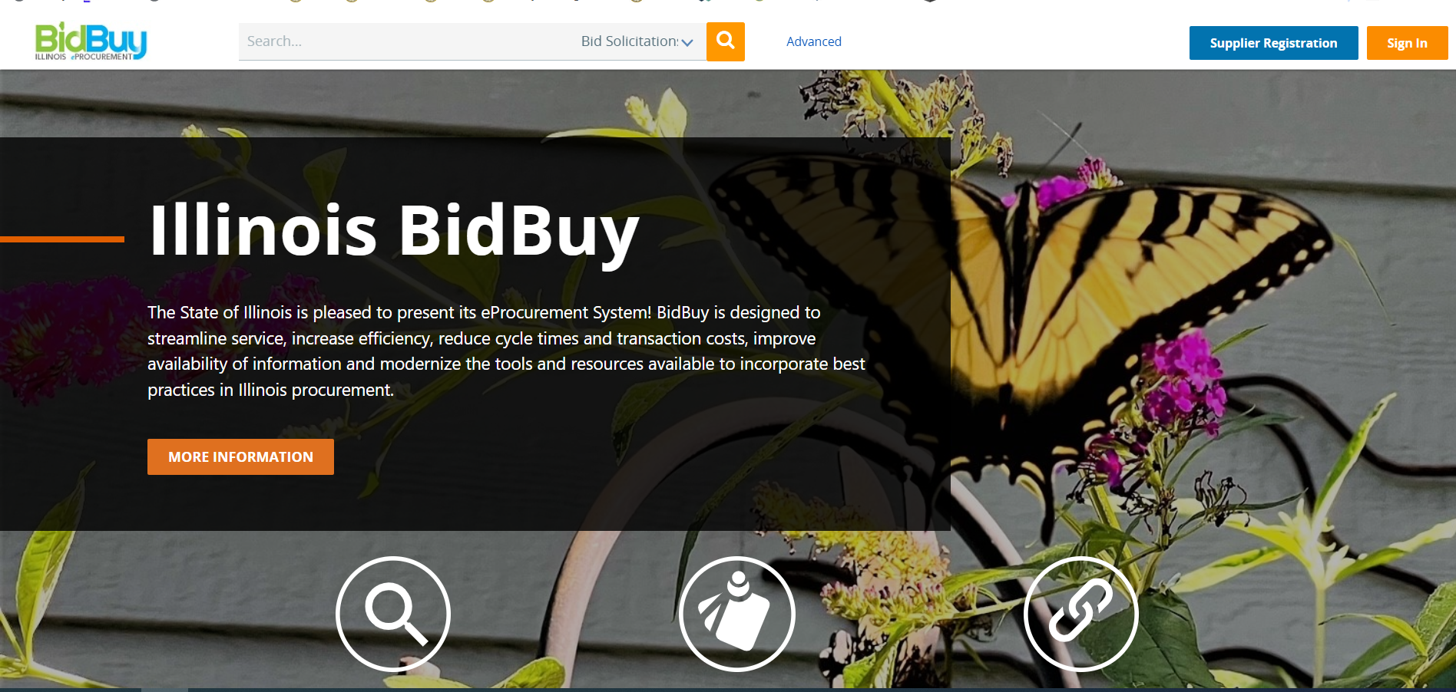

## Contract Search

Towards the Top of the BidBuy homepage, click on Advanced.



### After a few seconds, the following screen appears.

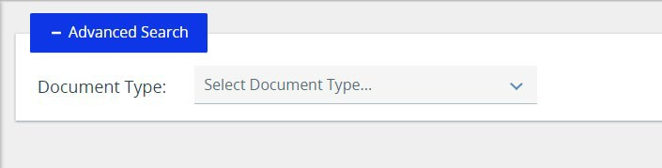

### Change the drop down to Purchase Orders and your search criteria fields will be available.

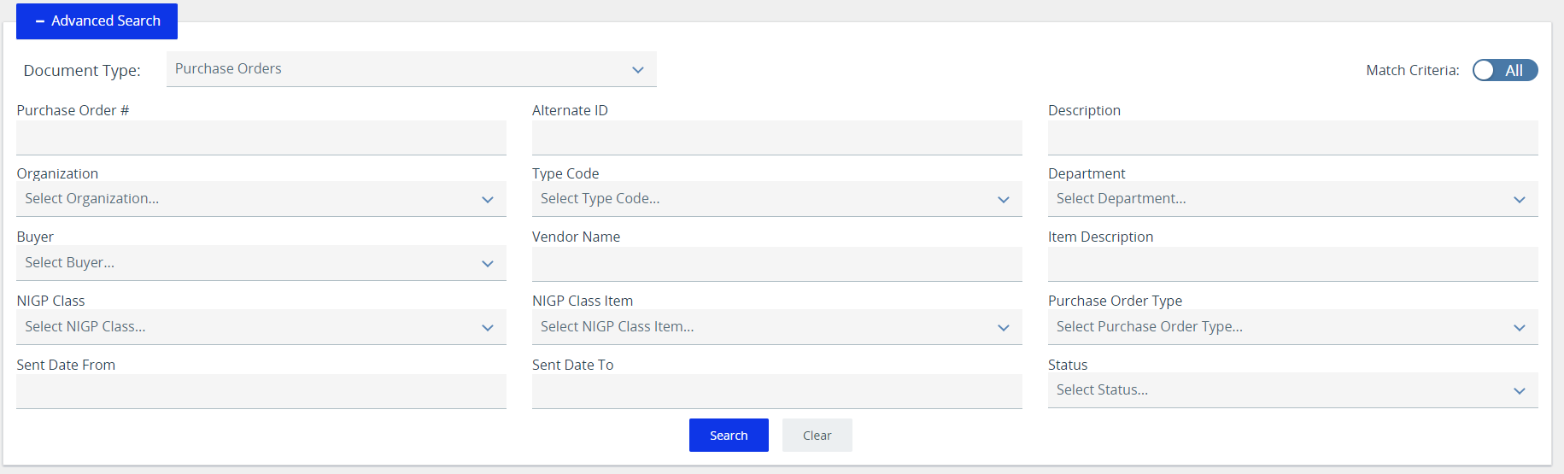

Enter data into Search Fields and/or click on the down arrow to see options in the drop-down box. Once you’ve selected all the search criteria, click **Search**.

Here’s an example of entering “Acunetix” into the Description field and clicking **Search.**

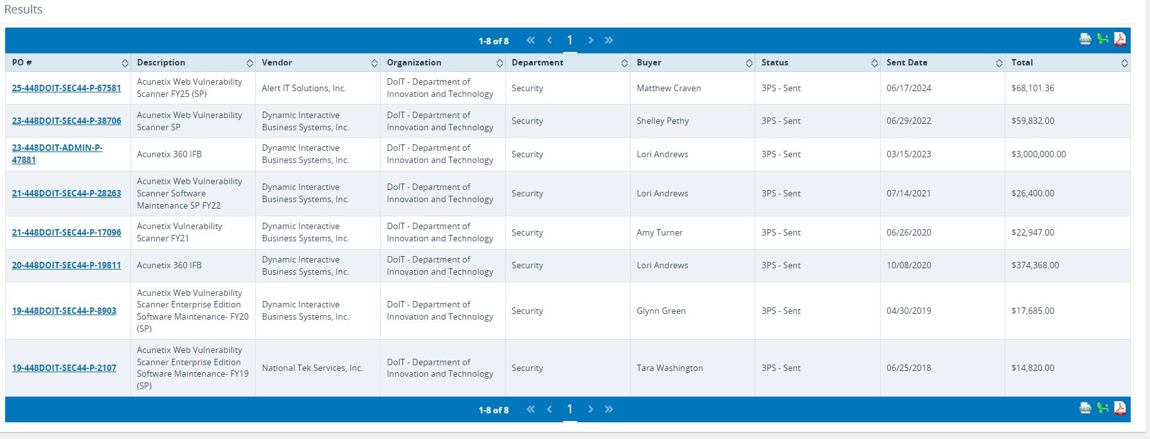

Click on the highlighted PO # from the list to review.

Please note: Any Purchase Order numbers that end with a colon followed by 2 or more numbers are for orders off of State of Illinois master contracts (example below). Those should be disregarded.

[**23-416CMS-BOSS4-P-52692:12422**](https://www.bidbuy.illinois.gov/bso/external/purchaseorder/poSummary.sdo?docId=23-416CMS-BOSS4-P-52692&releaseNbr=12422&external=true&parentUrl=close)

The following screens display the contract information. The Header Information provides overall contract information. If you have any questions regarding the contract, contact the person whose name is located next to the **Purchaser** column.

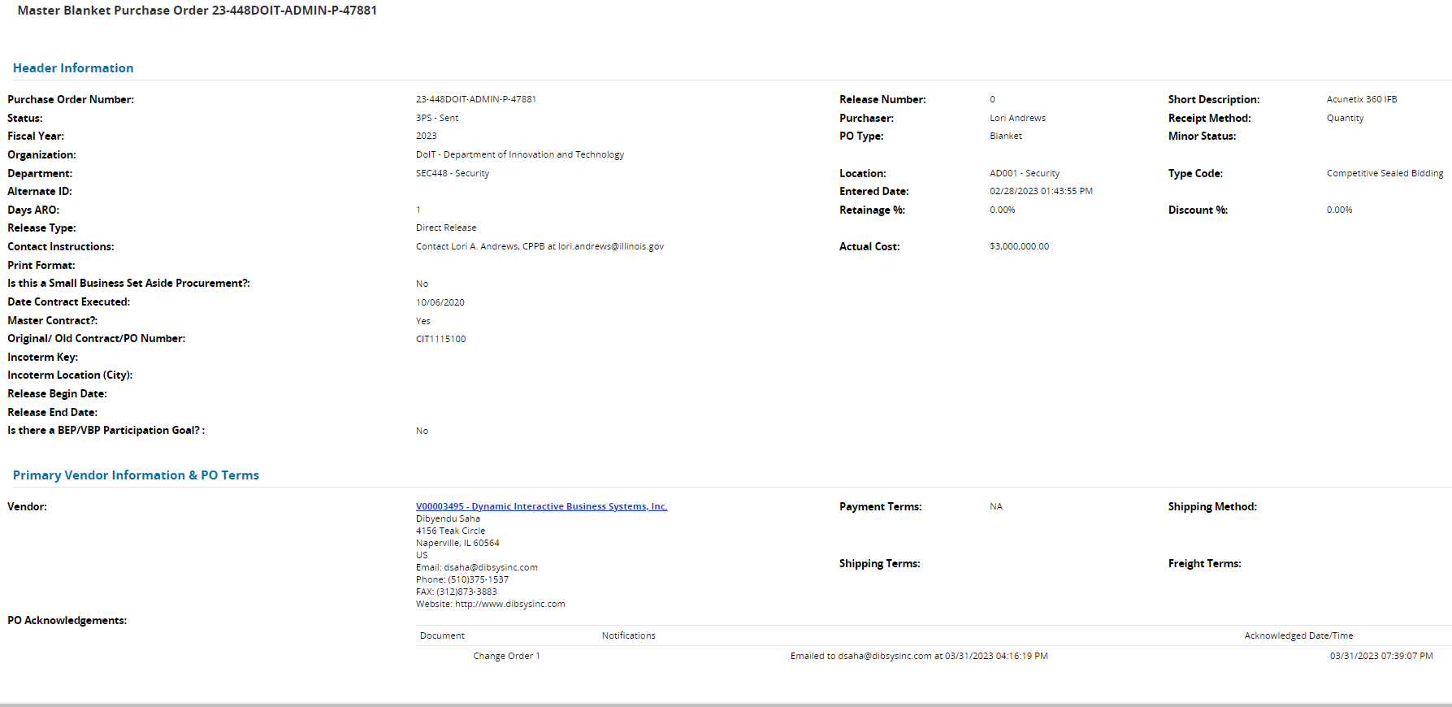

To open a copy of the contract document, next to the **Agency Attachment** column, click on the highlighted document name. If a copy of the contract is not available, please contact the Unified Procurement Program (UPP) team at [CPO.UPP@illinois.gov](mailto:CPO.UPP@illinois.gov). (JPMC contracts will have a contract attached, agency specific contracts will not be attached.)



Below the Item Information Header are the items, quantities, and costs associated with the contract.

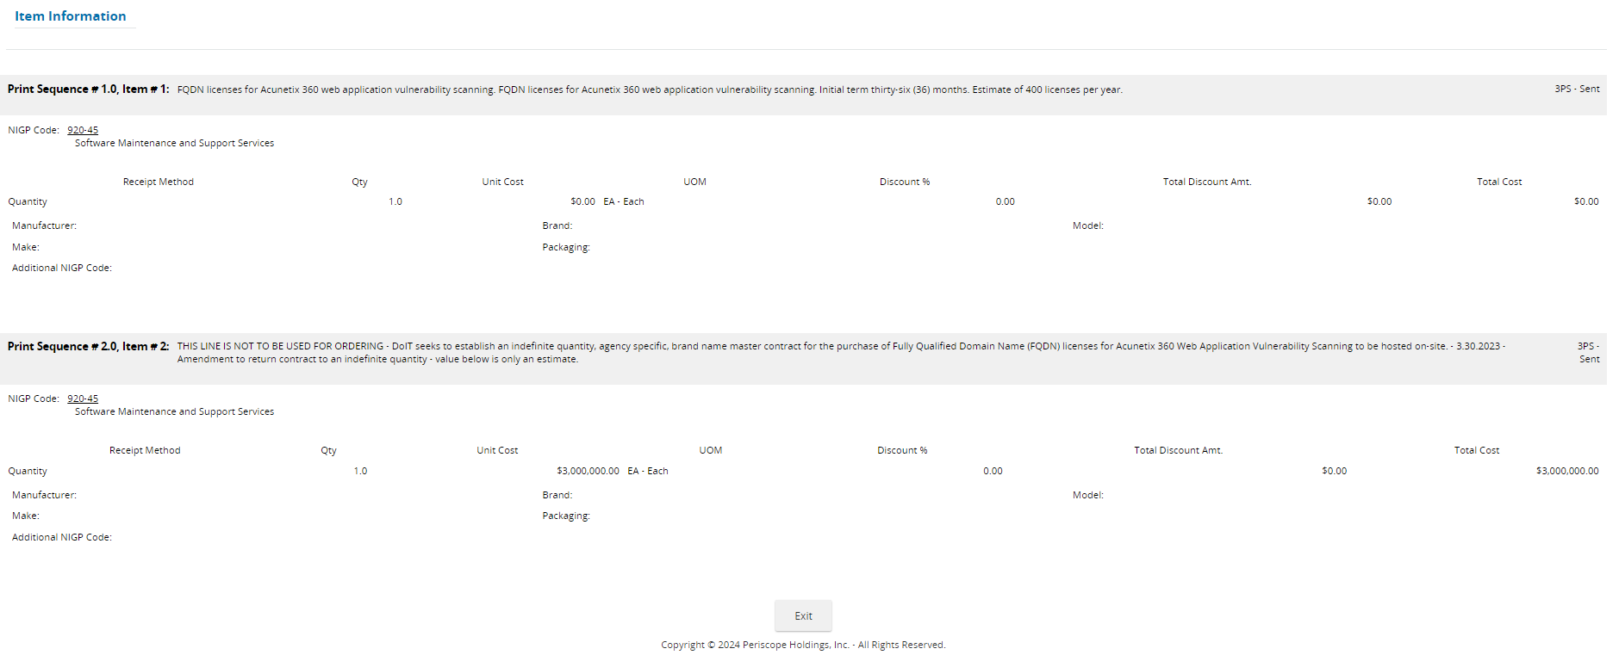

Click **Exit** to close the window.