NARCAN PURCHASE PROCEDURES – BidBuy #: 21-510CPOGS-CPOGS-P-25955

The Statewide Joint Purchase Master Contract for Narcan has been established via the MMCAP Infuse cooperative purchasing organization. Entities that purchase from MMCAP Infuse contracts must be members of MMCAP Infuse to access contract pricing. For more info on MMCAP Infuse see the box below:

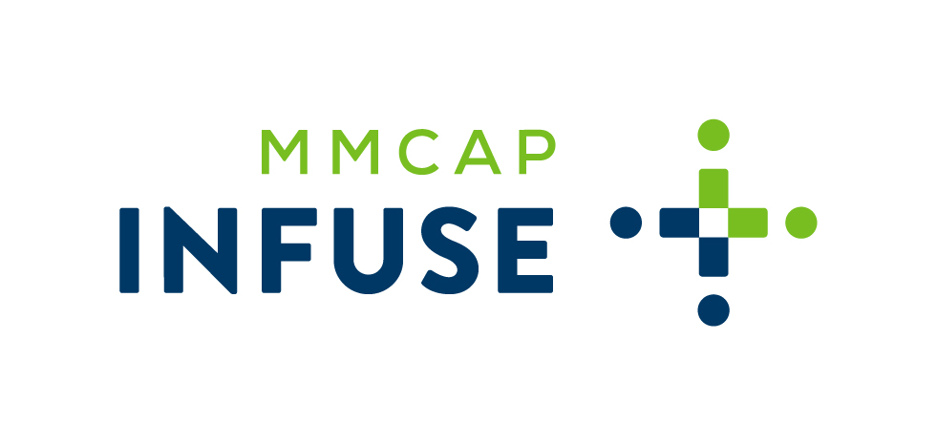
Membership is free and open to state agencies, counties, cities, school districts, federally recognized Indian tribes. To join MMCAP Infuse or verify your MMCAP Infuse ID, please contact mmcap_infuse.membership@state.mn.us.

If you have questions, please contact Michael Baumann, Senior Account Executive Michael.baumann@state.mn.us OR https://infuse-mn.gov/products/product-ordering/index.jsp

MMCAP Infuse Website: https://infuse-mn.gov/

Narcan Nasal Spray Purchases:
Step One: Apply for an MMCAP Infuse ID Number: https://infuse-mn.gov/about/membershipapp/index.jsp
Step Two: Contact Emergent Devices to provide your MMCAP Infuse ID # and a signed Letter of Authorization (LOA).
Step Three (for state agencies only): Complete the standard Release Off Master process in BidBuy.

CONTRACT VENDOR:
EMERGENT DEVICES INC.
401 Plymouth Rd. Suite 4000
Plymouth Meeting, PA 19462
narcancustomerservice@ebsi.com
1-844-4NARCAN (1-844-462-7226)

CONTRACT NO: MMS2000303 (MMCAP Infuse)
Terms: NET 30
Terms of Delivery: Three (3) Business Days FOB Destination

Remit Address:
Emergent Devices Inc.
PO BOX 65030
Baltimore, MD 21264

Forms:
MMCAP Infuse -- Application: https://infuse-mn.gov/about/membershipapp/index.jsp
Emergent Devices -- Letter of Authorization (LOA). This serves as the Rx Prescription. (Template is available in BidBuy)

