- To update your Illinois Procurement Gateway (IPG) application and continue participation in the Small Business Set-Aside Program (SBSP), follow these steps:

Log into your IPG vendor account here: https://ipg.vendorreg.com/
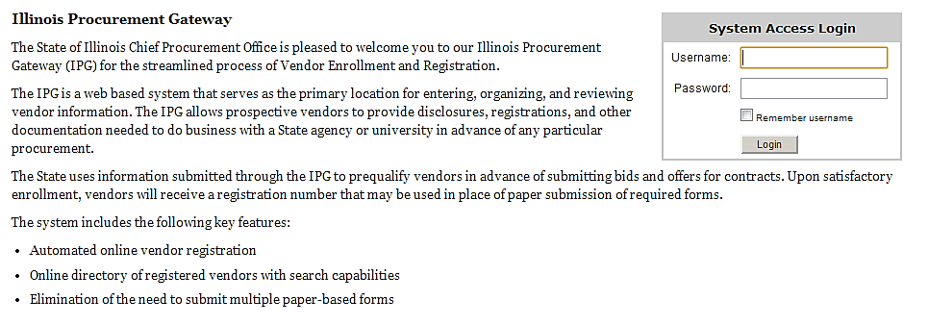
- If you've forgotten your password, then click on "Forgot Password" on the IPG home page. You will receive a temporary password via email. Please wait for the email to arrive and do not reset the password again before receiving the email.
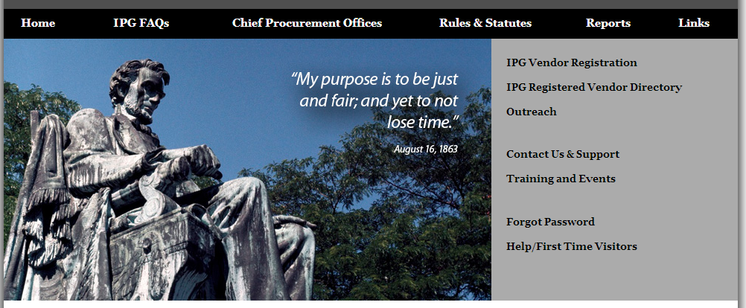
- You will see your “Dashboard”. Under "Key Actions" on the right side of the screen, click on "Start/Renew Vendor Registration". You will see a list of your vendor registrations.
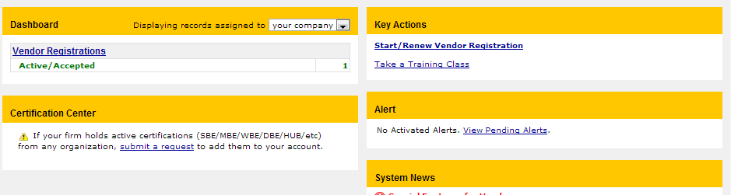

- Above the list, click the gray button marked "New Vendor Registration".
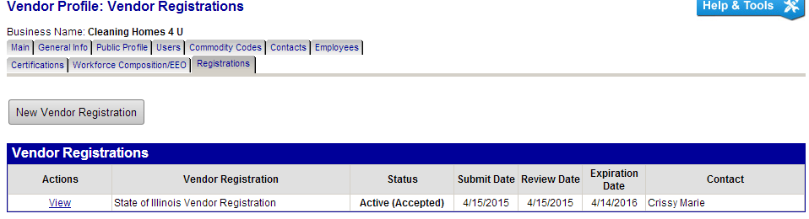
- From the list of Available Vendor Registrations, click "State of Illinois Vendor Registration".
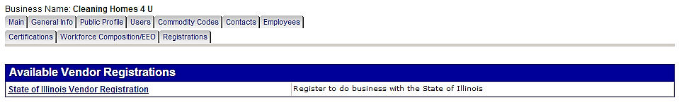
- You will see a box titled "Vendor Registration Autofill Options". Select the registration you want to use to auto fill a new registration. If you have an "Active" registration, you should select that one.
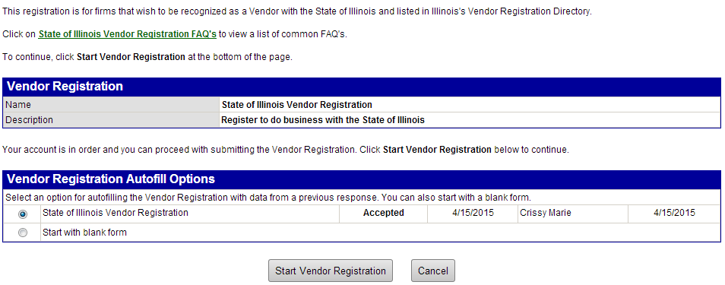
- Each form section will be colored red. You will need to go through each form and make any necessary changes or none at all. Once a form is complete click “Save and Return” at the bottom of each form section. The form section will turn green.
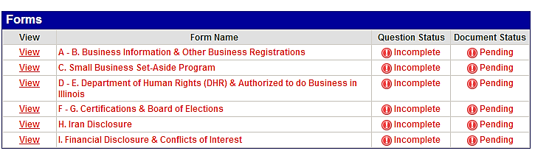

- View of Completed Forms
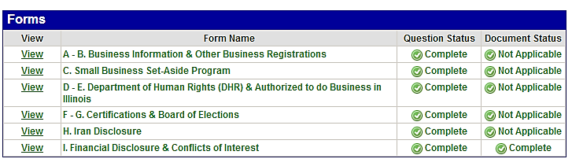
- Action is required in form C. Small Business Set-Aside Program. Either attach your most recent tax documents or attach a completed Small Business Set-Aside Program Re-Qualification Statement. The statement can be downloaded here: . Name your file appropriately. Do not delete previous tax documents.

- To attach your updated tax documents or statement, click on the red word Attach. A pop-up box will appear that allows you to attach the tax documents or statement.
In the pop-up box click the "Choose File" link to open the window to choose your file. Locate your file, then click on it twice so it will appear in the "Select File" box. Name the file appropriately.
Click the "Attach File" box to attach the file then click the "Close Window" box to close the pop-up.
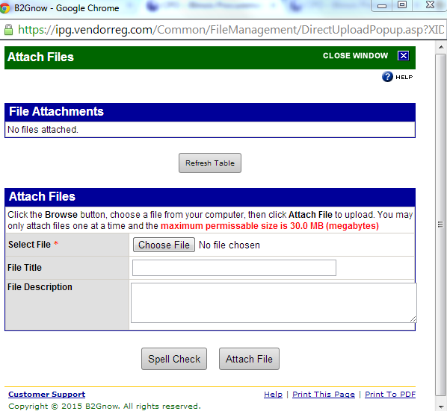

Click the "refresh" link by the Status on the far right to see your attached file. Now your file should appear in the box.
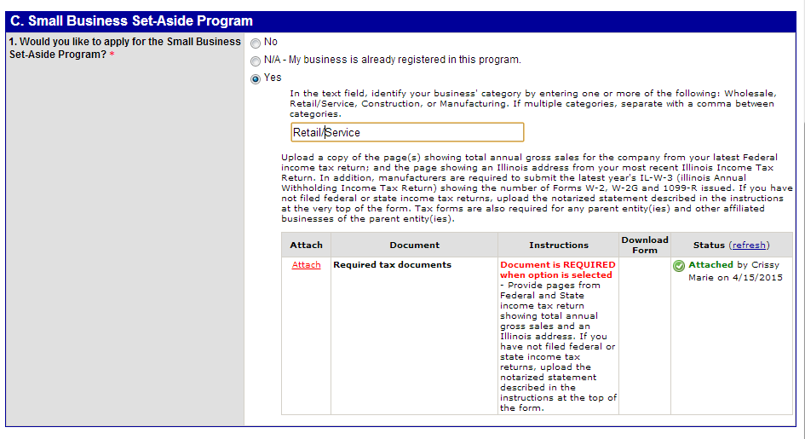
- Click “Save and Return”

- Action is required in form F – Certifications. Question #6 has been modified removing the option to select “N/A”. Please review to ensure you have either marked Yes or No.

- Action may be required in form I – Certifications. This only applies if you previously registered as a Sole Proprietor. Question #1 has been modified requiring the Sole Proprietor’s name to be entered.
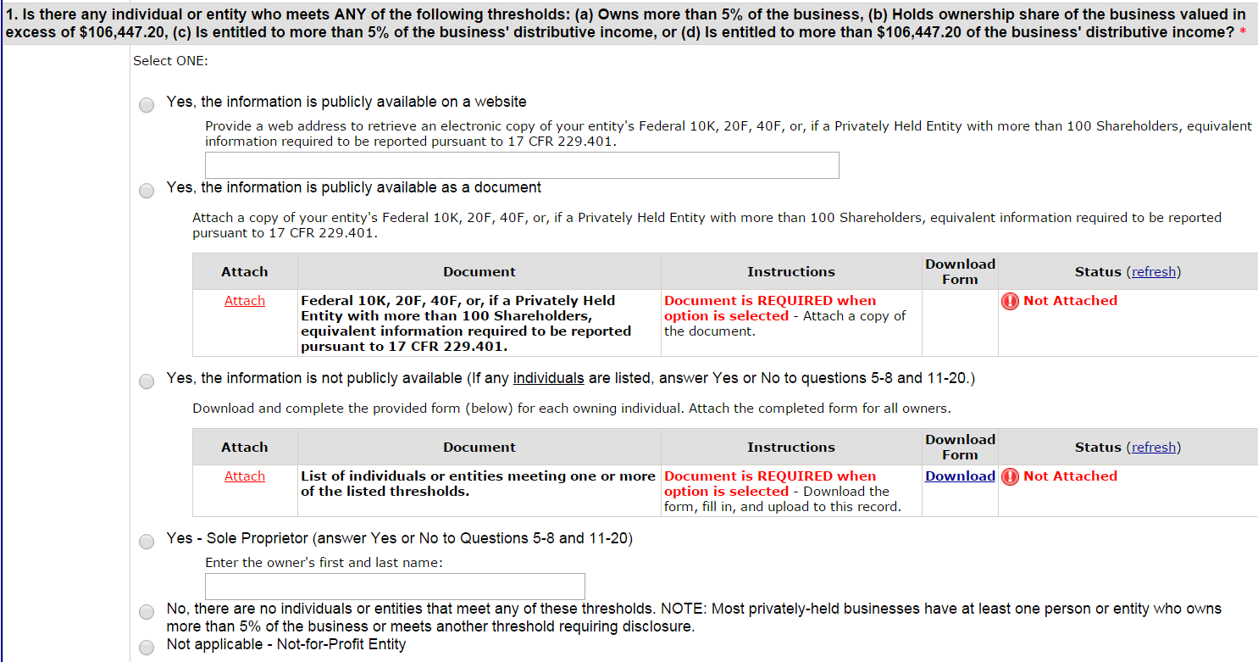

- After completing each form and attaching any necessary documents, you may now click "Next".
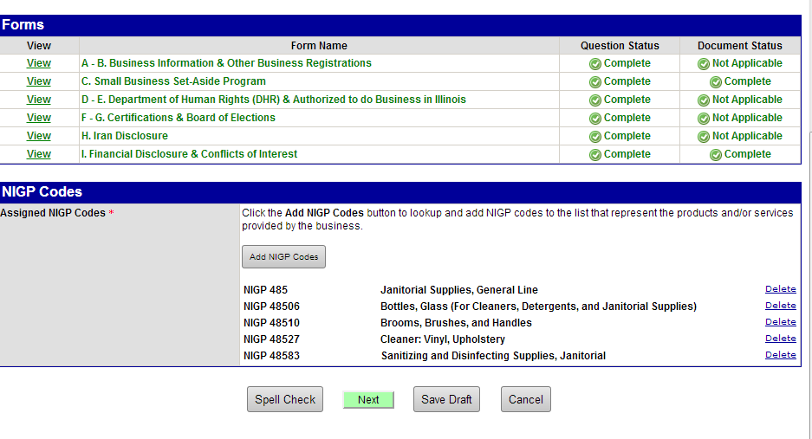

- Sign your application electronically and click “Submit”.
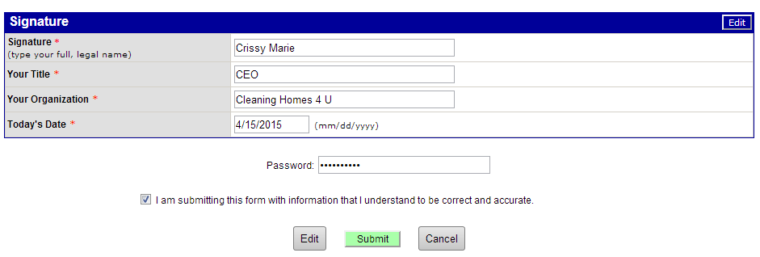
You will receive an email notification that your IPG application has been accepted. Within 7-14 business days of acceptance, you will receive a SBSP certification letter.

